# [DIY a Wi-Fi Speaker with LinkIt Smart 7688](http://www.seeed.cc/project_detail.html?id=1076)

# [http://www.seeedstudio.com/wiki/Breakout_for_LinkIt_Smart_7688_v2.0#Hardware_Overview](http://www.seeedstudio.com/wiki/Breakout_for_LinkIt_Smart_7688_v2.0%23Hardware_Overview)

# Breakout_for_LinkIt_Smart_7688_v2.0_schematic_

# Breakout for LinkIt Smart 7688 v2.0 hardware connections 1200 s.jpg

# *富威集團代理產線Wolfson 推出WM8960多媒體盒解決方案。WM8960是一款低功耗、高質量Stereo Codec，專為可攜式多媒體應用設計。WM8960內建1W Stereo Class D Speaker Driver，提供8W負載的每聲道1W輸出，確保低漏電，出色的電源抑制比和PoP Noise抑制。*

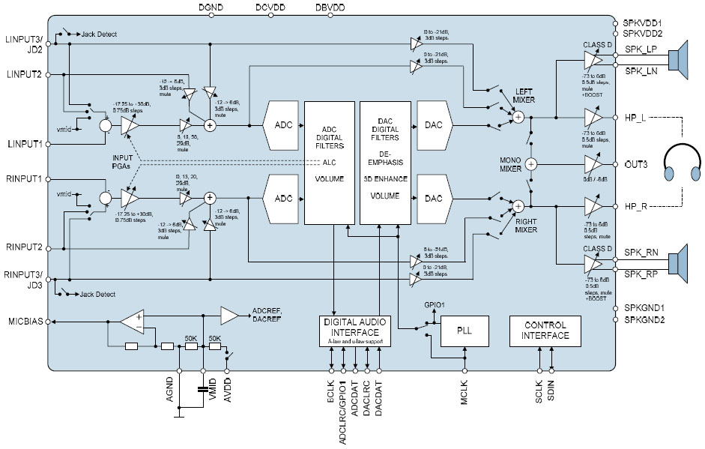

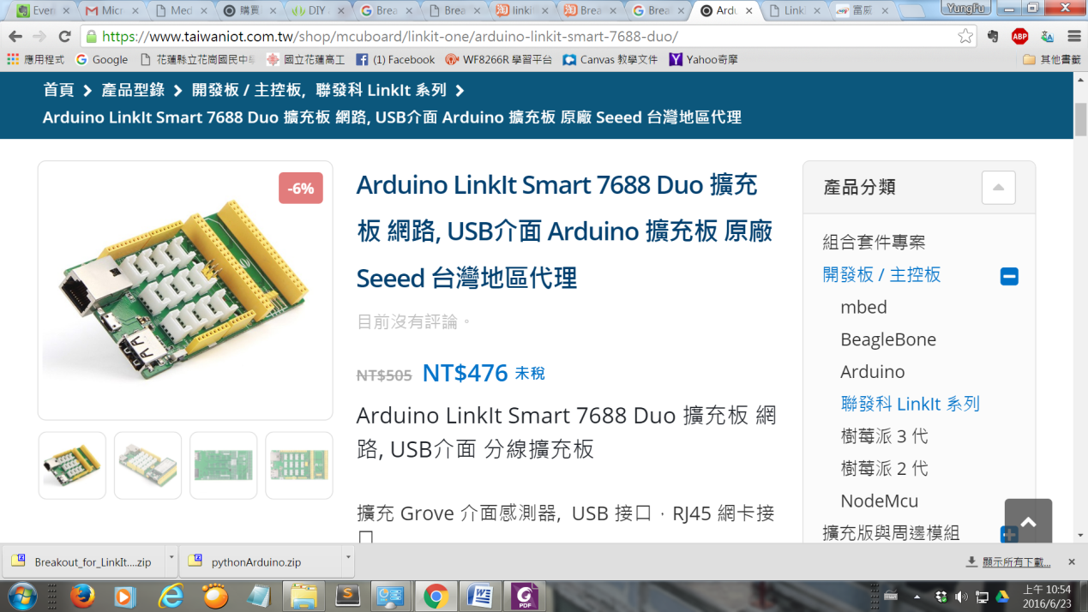

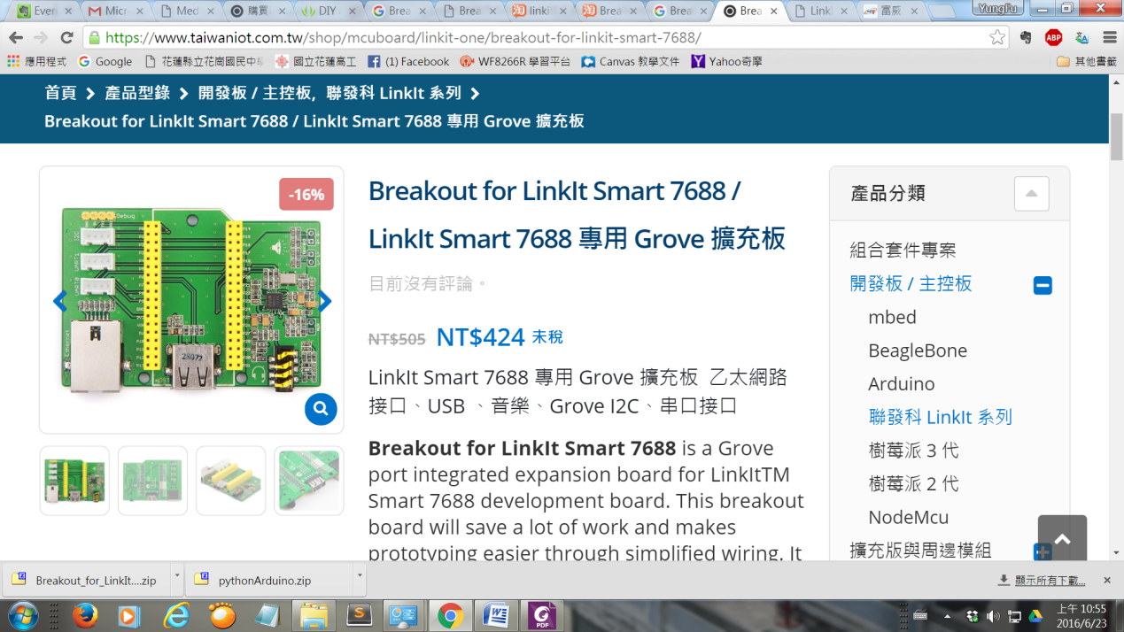

# LinkIt Smart 7688

## Audio on LinkIt Smart 7688

[該LinkIt智能7688有一個I2S接口，我們可以用它來開發音頻應用。要得到音頻信號的工作，需要額外的硬件，例如，從Seeed的接口板。](https://github.com/xiongyihui/LinkIt_Smart_7688/blob/master/README.md)

[Linkit 7688 play mp3 or wav](https://github.com/xiongyihui/LinkIt_Smart_7688/blob/master/README.md) or usb sound card

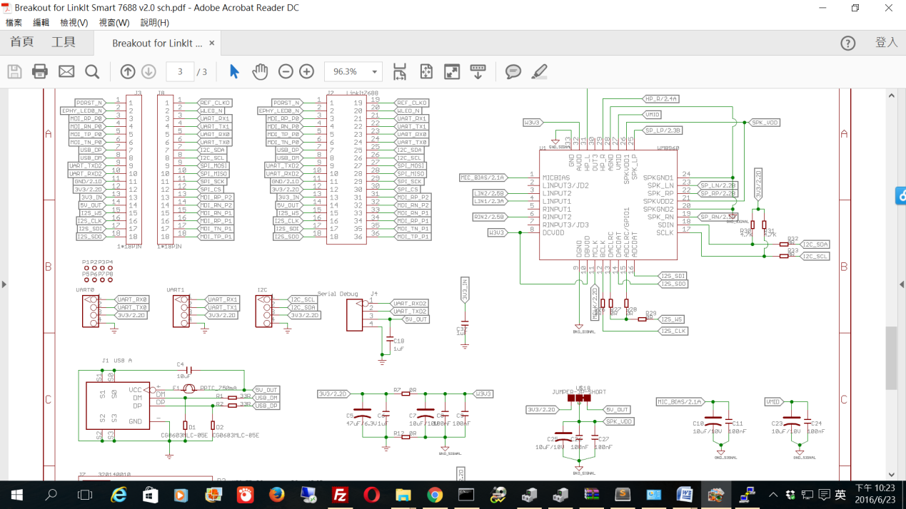

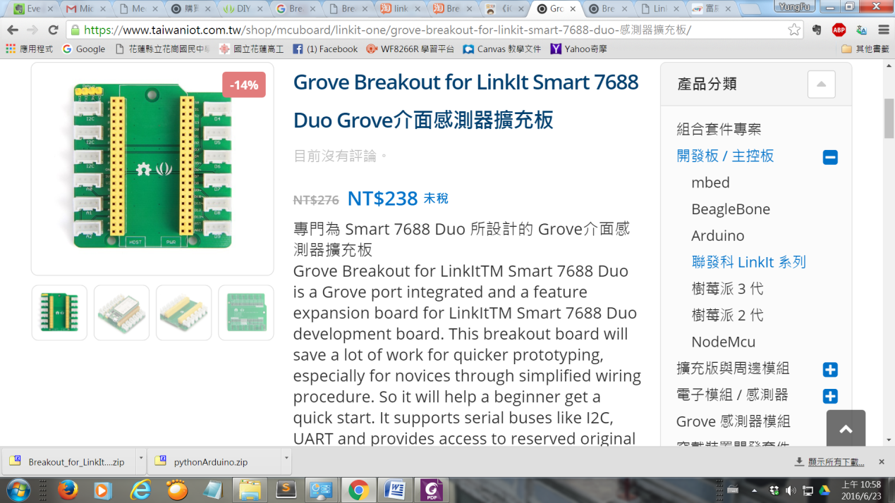

## 

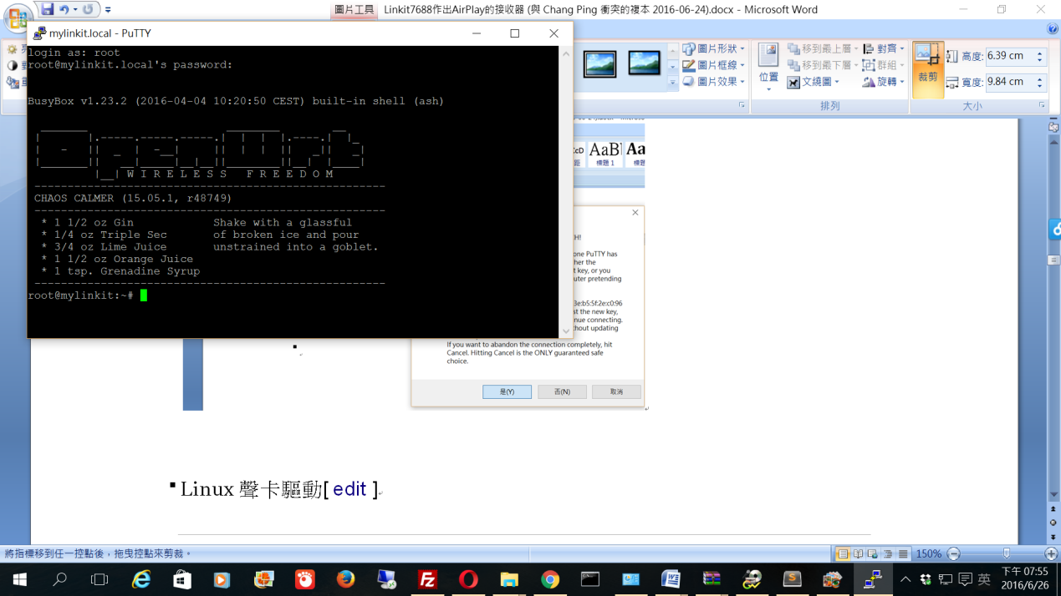

# Enable sftp, work around https://trac.cyberduck.io/ticket/4161

opkg update

opkg install openssh-sftp-server

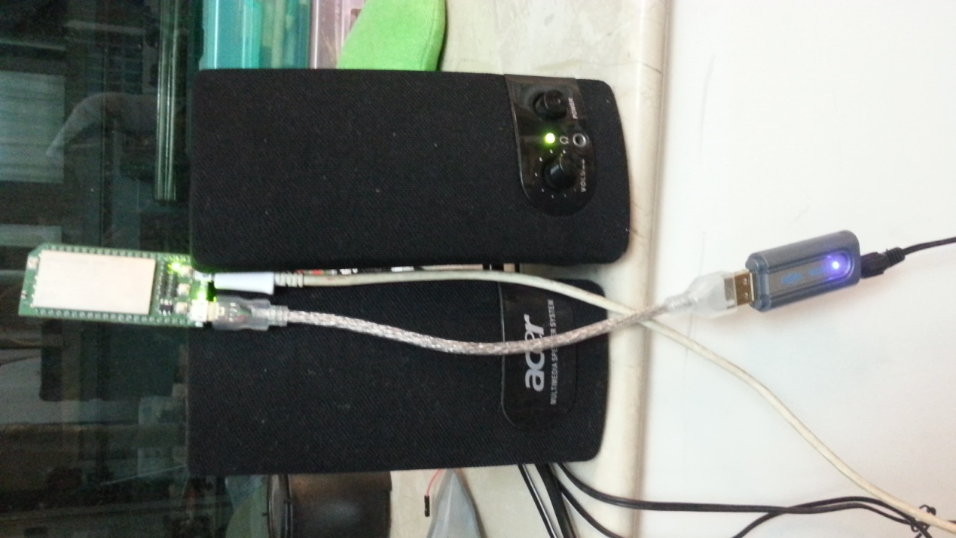

speaker amplifier

usb sound card

OTG

OpenWrt的安裝USB聲卡驅動程序

opkg update

opkg install kmod-sound-core

opkg install kmod-usb-audio

opkg install madplay (linkit 7688 duo預安裝)

[**OPKG 软件包管理**](https://wiki.openwrt.org/zh-cn/doc/techref/opkg)

**opkg list-installed**

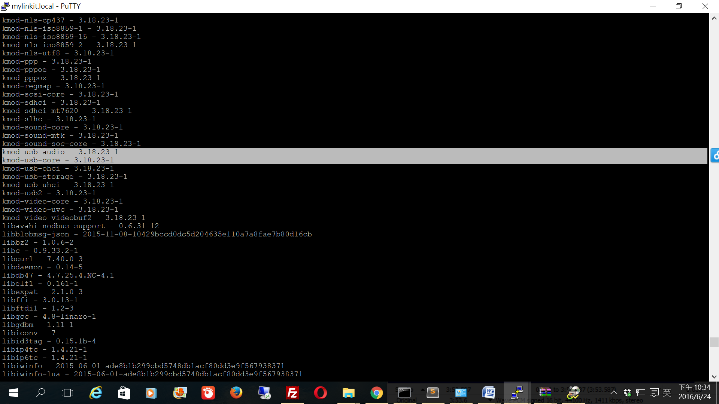

opkg install usbutils

lsusb

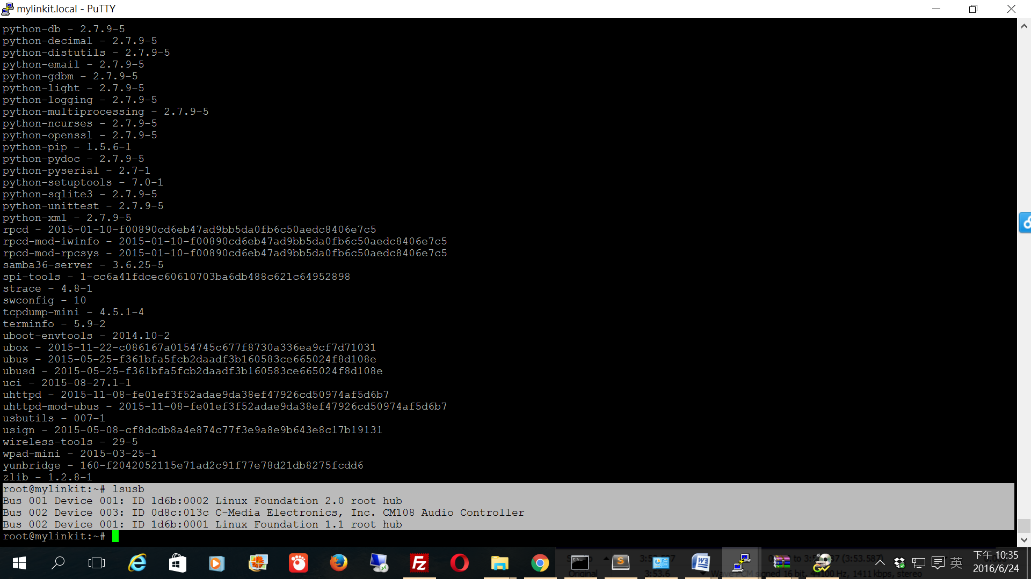

aplay -Dhw:1 /IoT/Example/music/blueTree.wav

madplay -o wave:- /IoT/Example/music/blueTree.mp3 | aplay -D plughw:1

madplay -o wave:- /Media/USB-A1/BecauseYouLovedMe.mp3 | aplay -D plughw:1

wget -O - http://50.7.96.210:8360 | madplay - -a+5 -o wave:- | aplay -D plughw:1

curl http://50.7.96.210:8360 | madplay - -a+5 -o wave:- | aplay -D plughw:1 (#test OK)

madplay -o wave:- /三寸天堂.mp3 | aplay -D plughw:1 (#test OK)

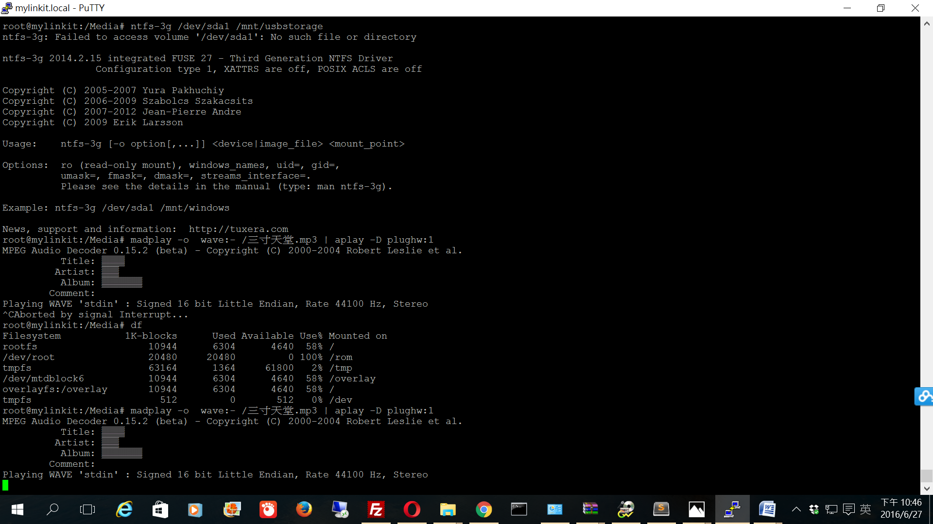

LinkIt Smart 7688 Duo的USB hub如何讀取USB碟及外接SD卡

check /Media/...

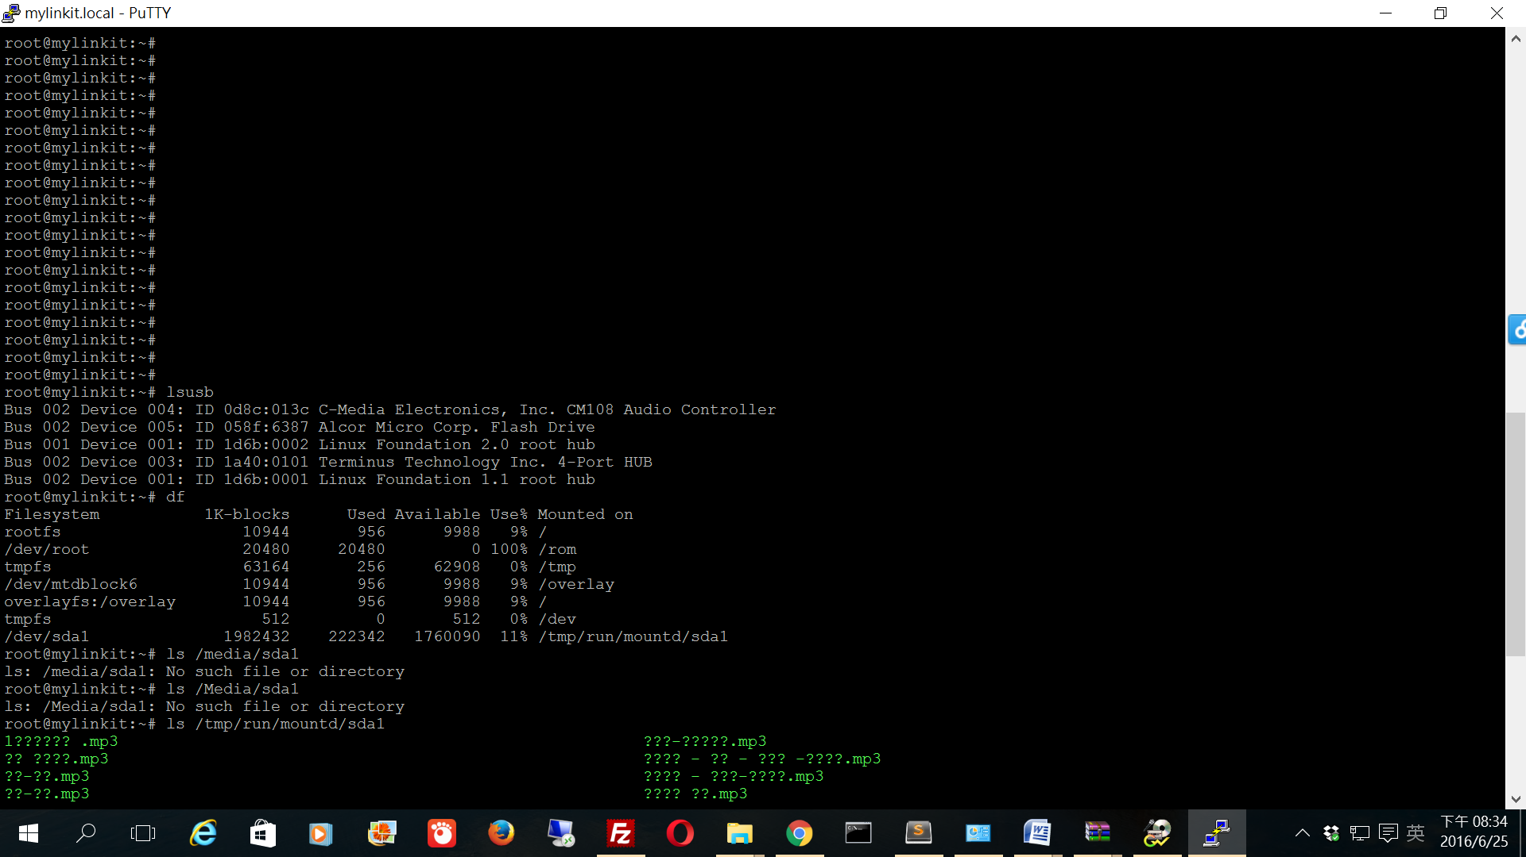

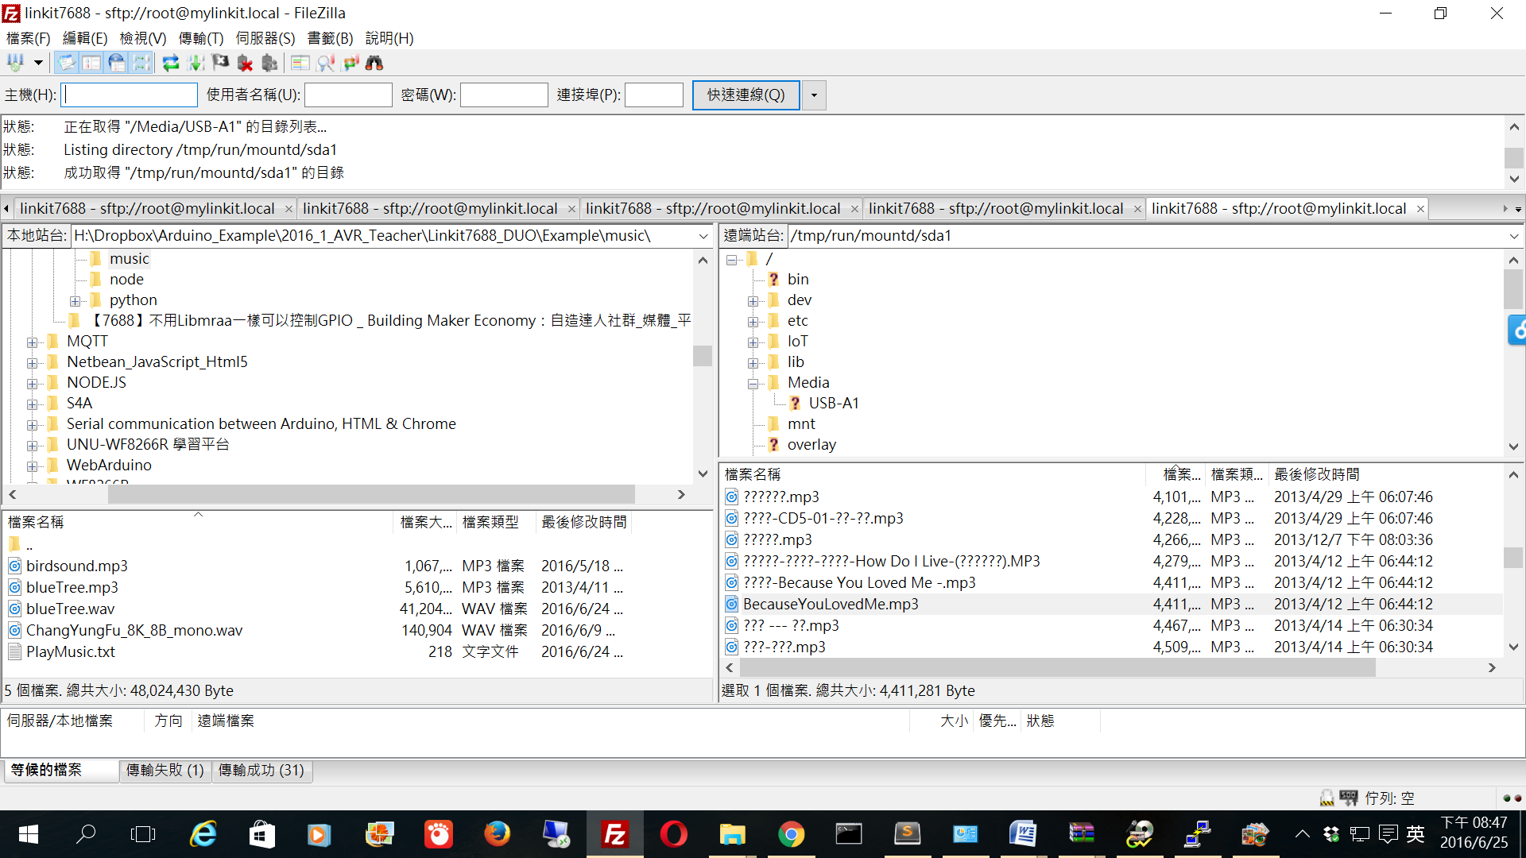

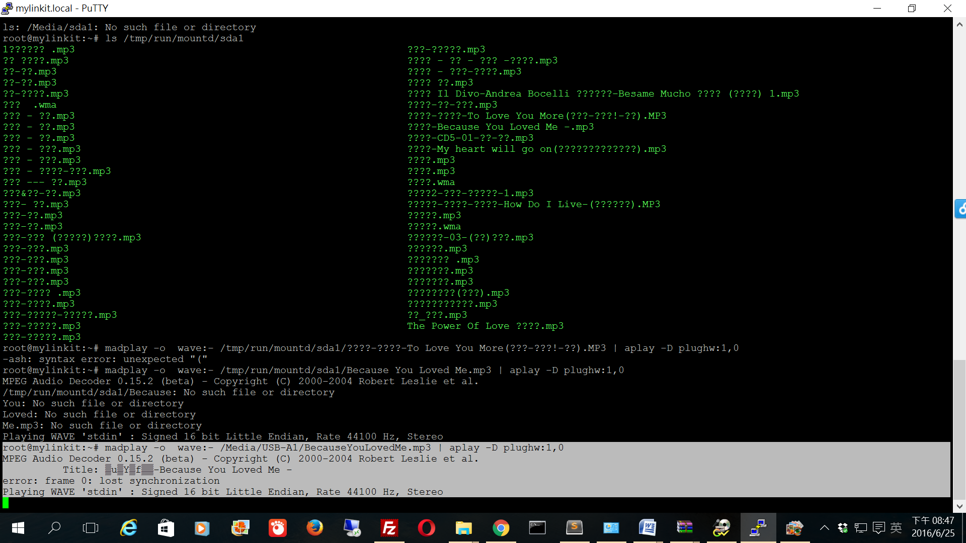

[//----------------------------Airplay](https://github.com/xiongyihui/LinkIt_Smart_7688/blob/master/README.md)

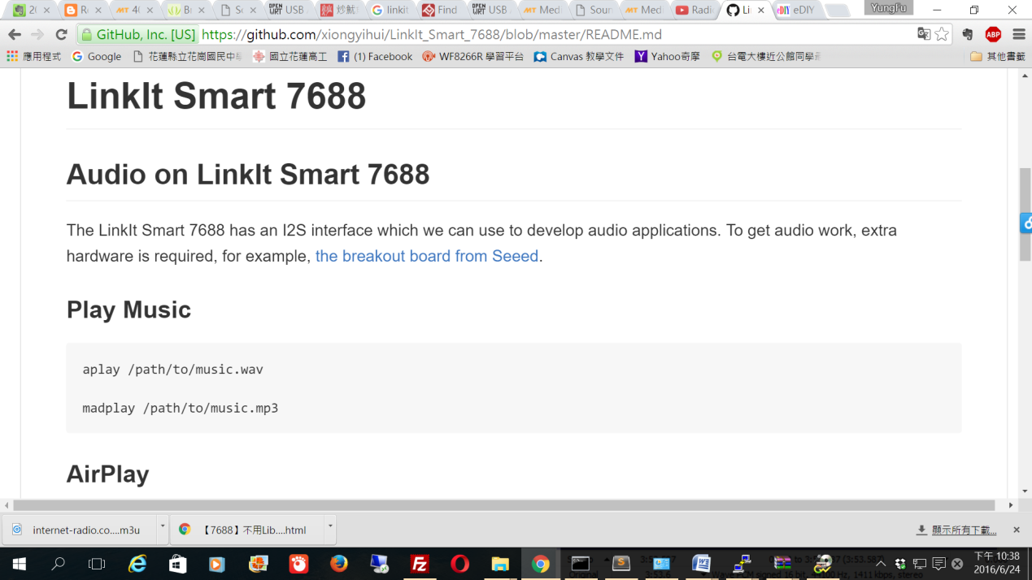

1 Shairport

We patch shairport with [002-use_mmap.patch](https://github.com/xiongyihui/LinkIt_Smart_7688/blob/master/shairport_patch/002-use_mmap.patch), use mmap to improve the performance and package [a new revision shairport ipk](https://github.com/xiongyihui/LinkIt_Smart_7688/blob/master/shairport_2014-10-28-2_ramips_24kec.ipk).

download shairport_2014-10-28-2_ramips_24kec.ipk to PC

copy shairport_2014-10-28-2_ramips_24kec.ipk to /tmp

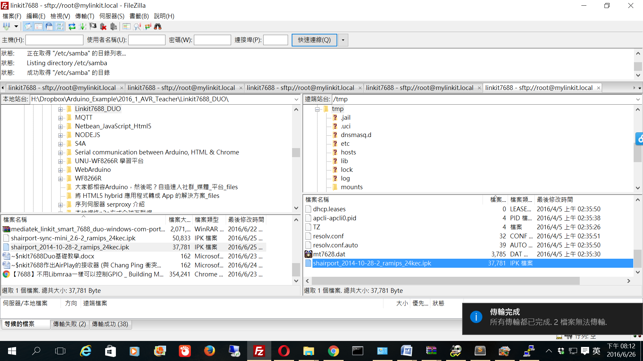

opkg update

opkg install libdbus

opkg install /tmp/shairport_2014-10-28-2_ramips_24kec.ipk --force-checksum --force-overwrite

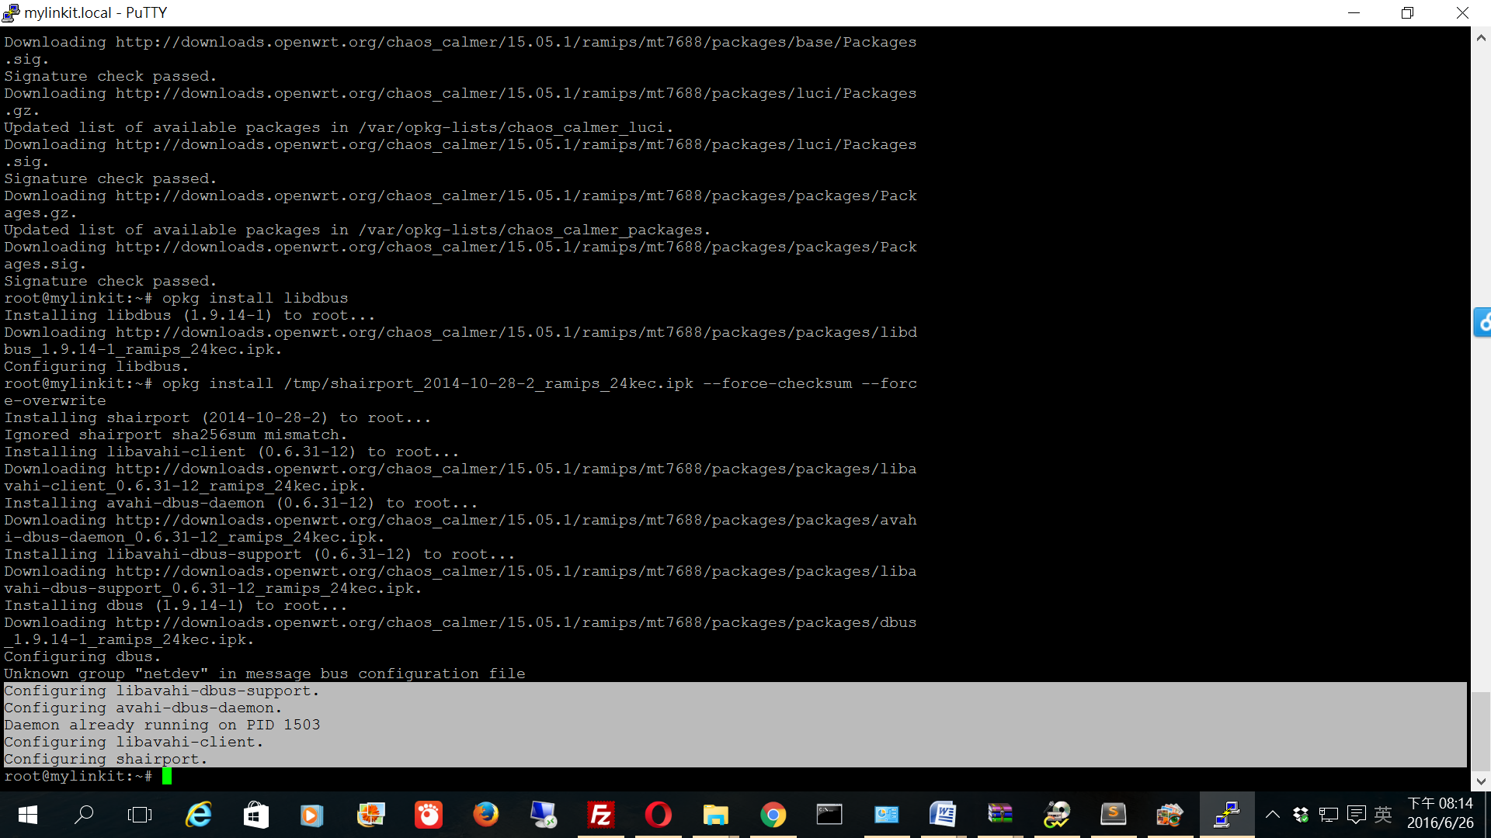

shairport 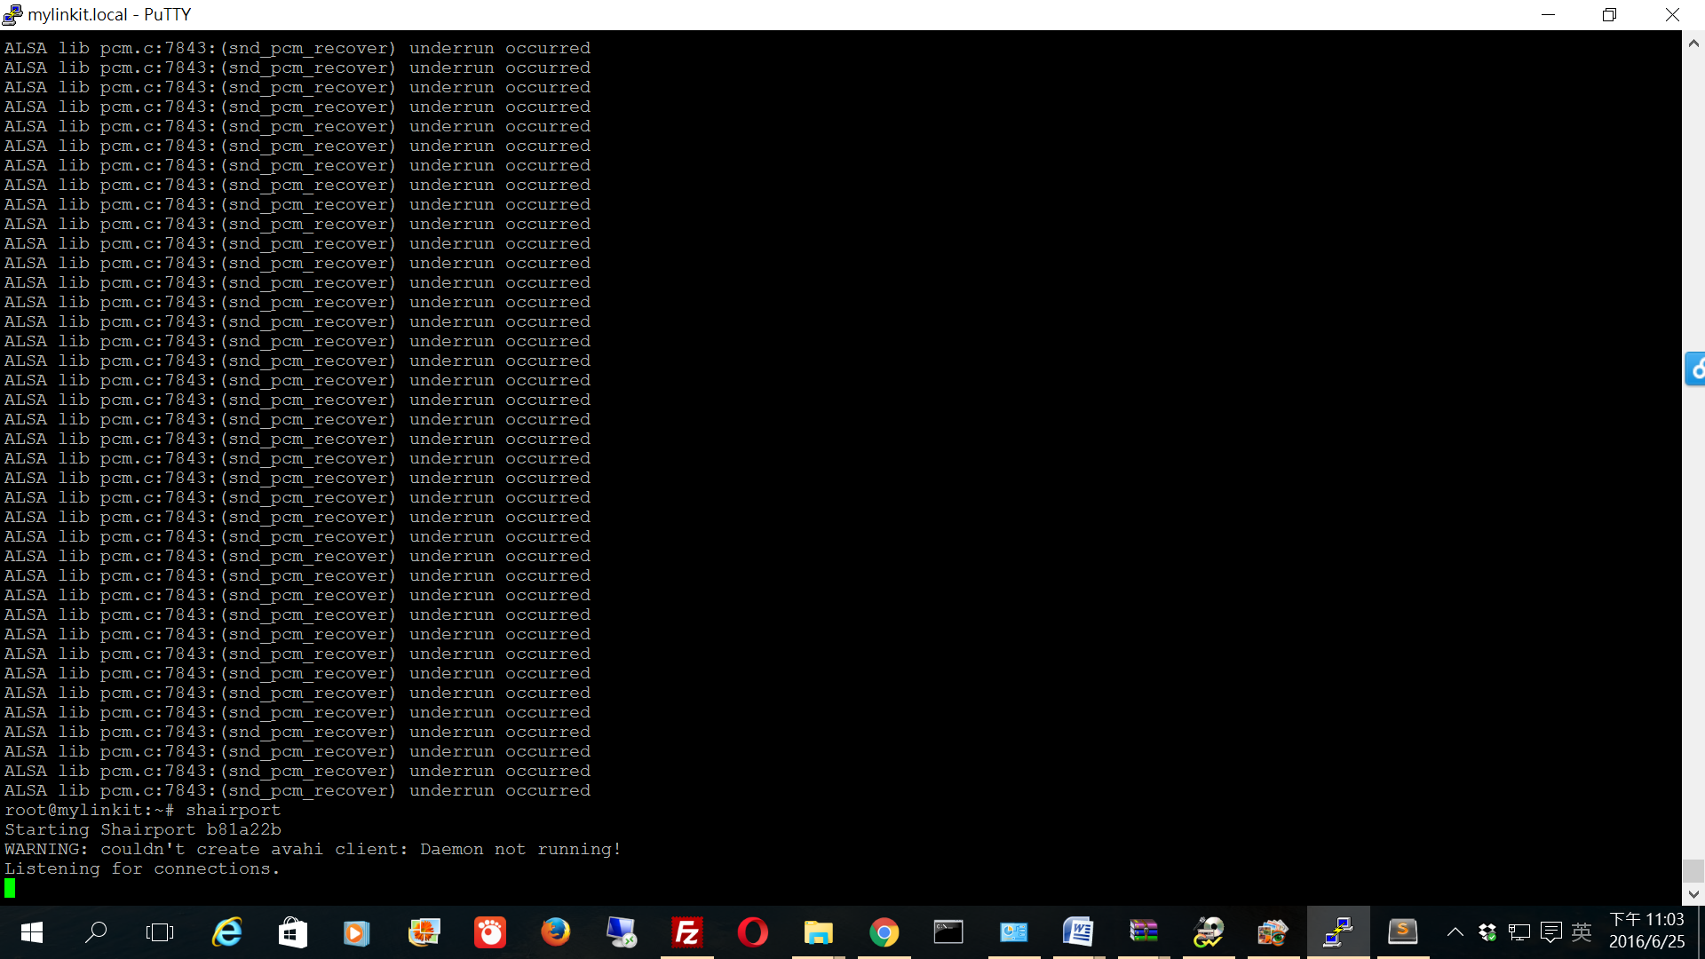

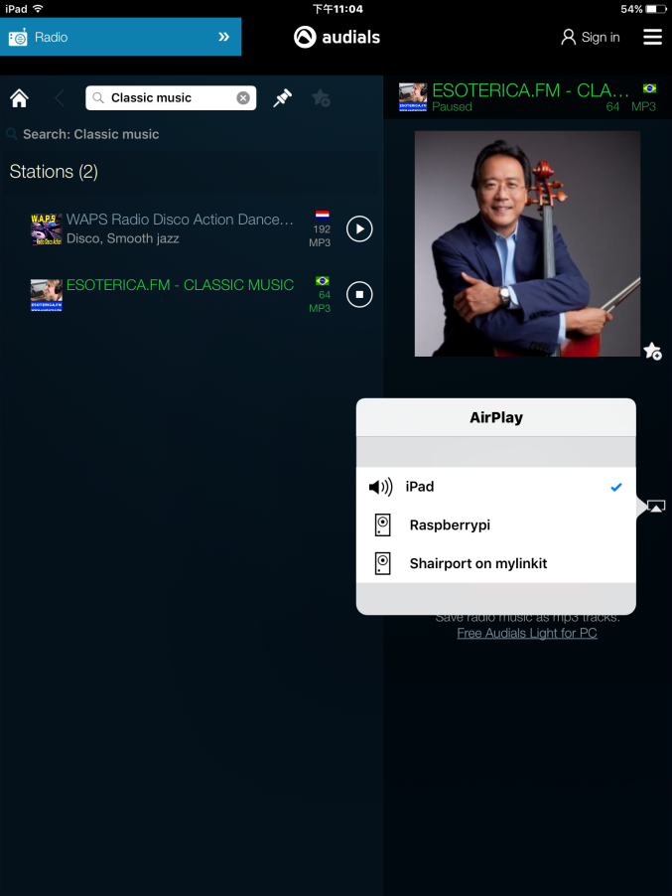

but ipad connect Shairport on mylinkit cause error

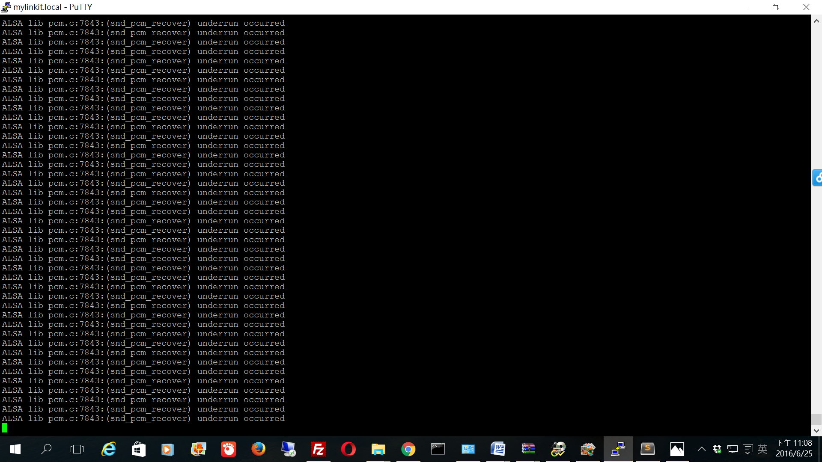

*install shairport-sync-mini_2.6-2_ramips_24kec.ipk(*測試成功2016/6/26*)*

download shairport-sync-mini_2.6-2_ramips_24kec.ipk to PC

copy shairport-sync-mini_2.6-2_ramips_24kec.ipk to /tmp

opkg install /tmp/shairport-sync-mini_2.6-2_ramips_24kec.ipk --force-overwrite

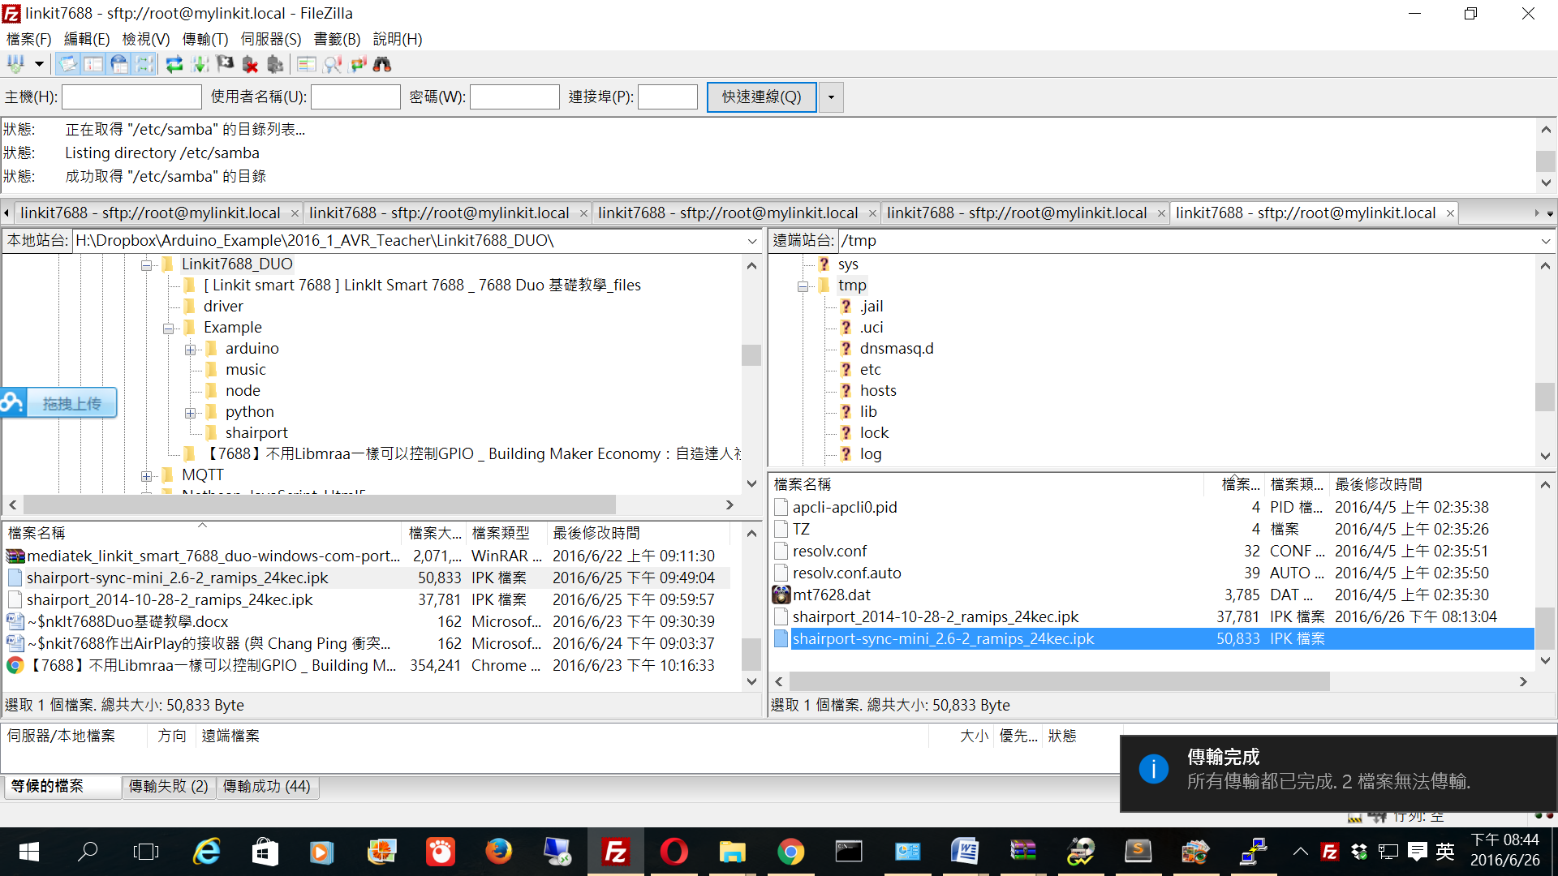

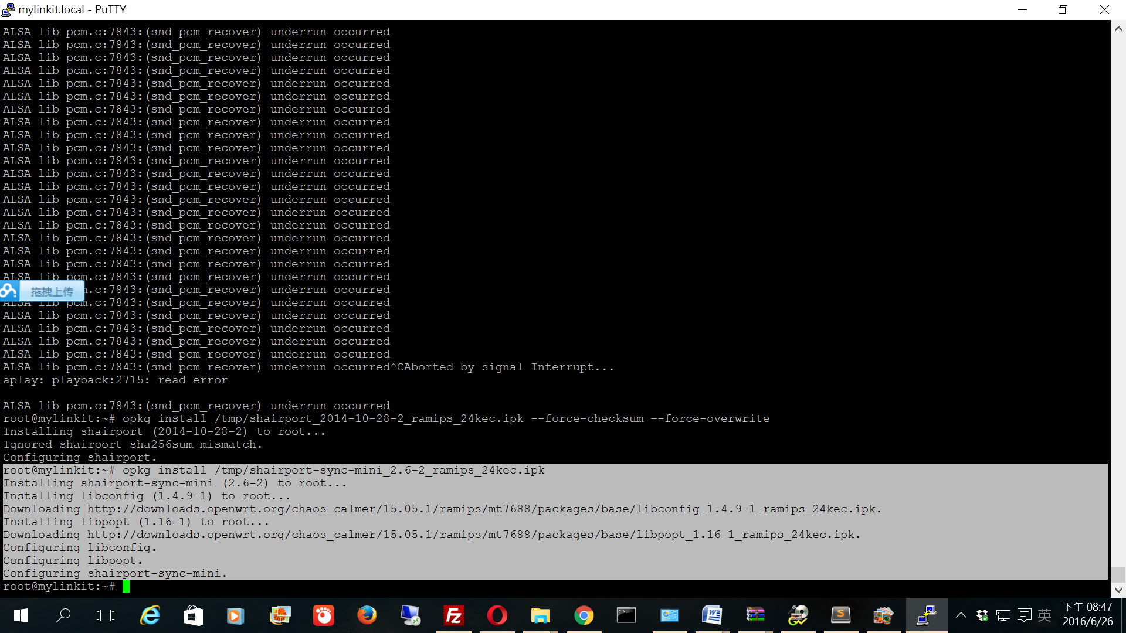

run ==>shairport-sync 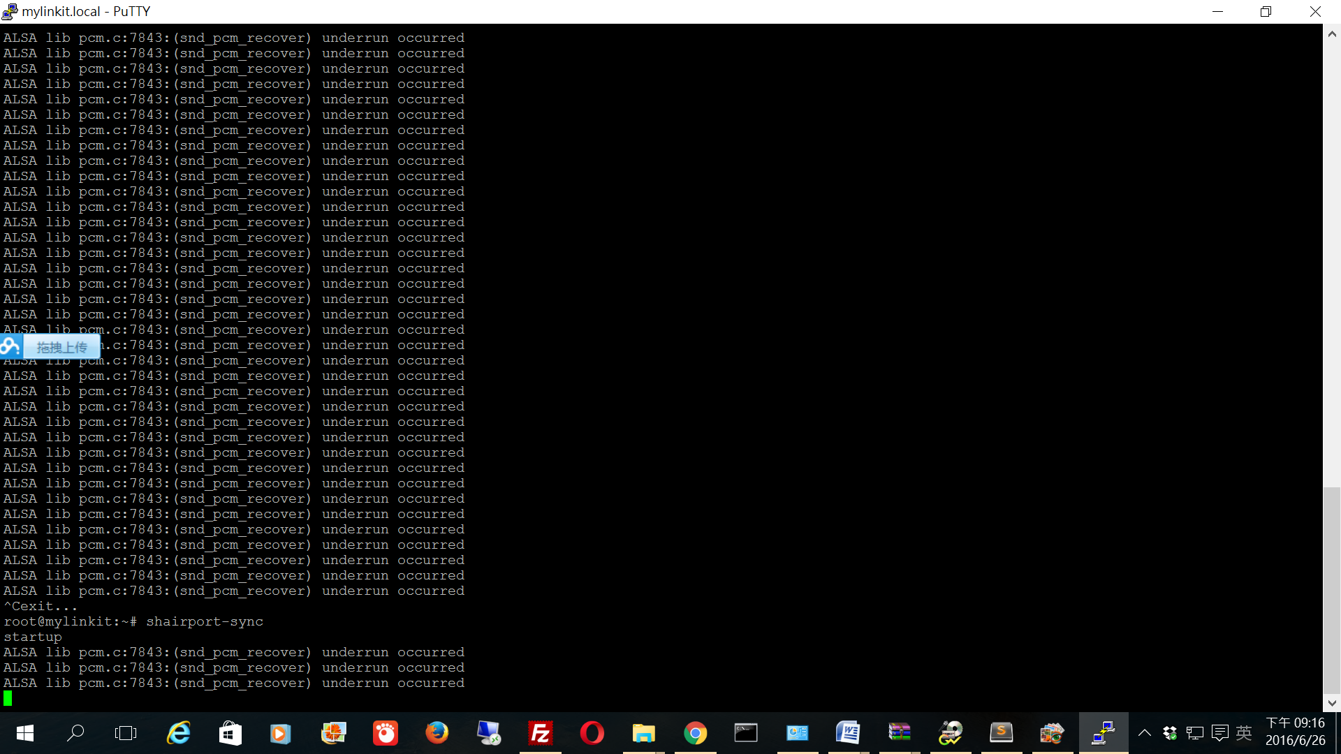

當iPad連接linkit7688 DUO==>(snd_pcm_recover）發生數據不足錯誤

修復shairport-sync.conf，配置

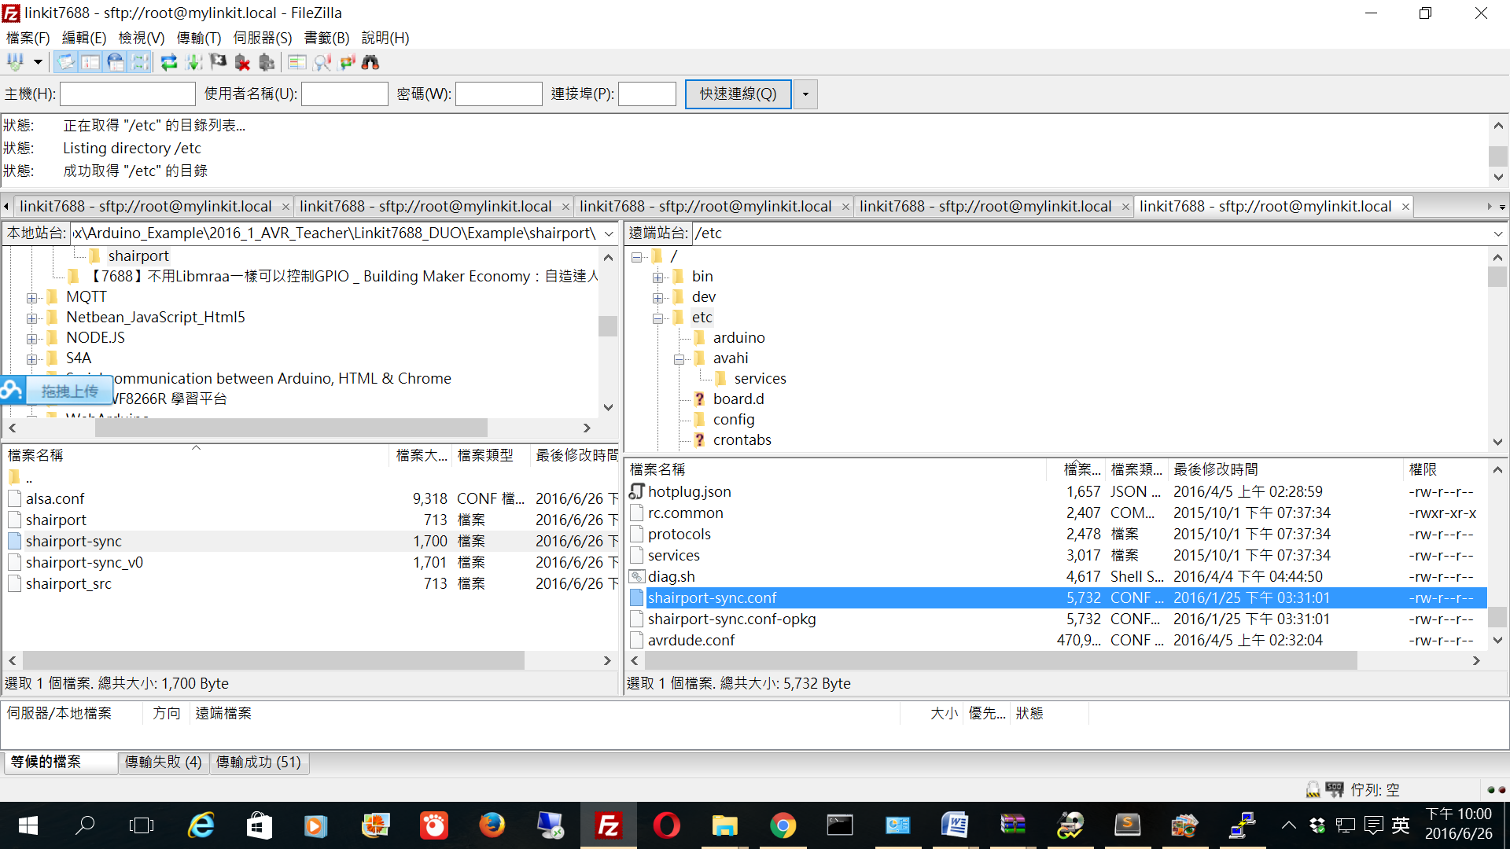

**注：配置文件主要設置general和alsa這兩部分就可以運行了，如果想深入研究其他參數，可以看看他配置文件裡面的註釋。**

編輯配置文件： /etc/shairport-sync.conf

general = { name = "Shairport-sync-ChangYungFu";#這個就是你手機里要顯示的設備名稱， #The default is "Shairport Sync on <hostname>"};

alsa = {

  output_device = "hw:1";#這裡要配置音頻輸出的設備編號,轉到USB聲卡。

};

output_device = "hw:1"; #這裡要配置音頻輸出的設備編號。

這個編號怎麼獲得呢，要通過這個命令：

aplay -l

root@mylinkit:~# aplay -l

**** List of PLAYBACK Hardware Devices ****

card 0: I2S [MTK APSoC I2S], device 0: WMserious PCM wm8960-hifi-0 []

Subdevices: 1/1

Subdevice #0: subdevice #0

card 1: Device [USB PnP Sound Device], device 0: USB Audio [USB Audio]( #USB聲卡)

Subdevices: 1/1

Subdevice #0: subdevice #0

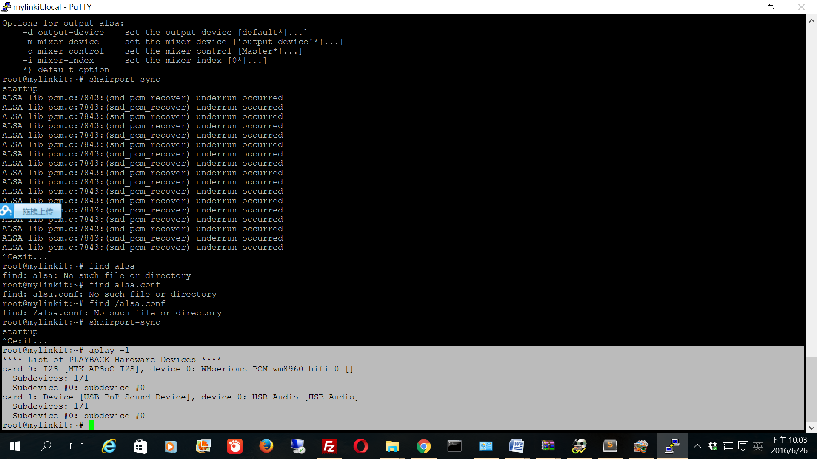

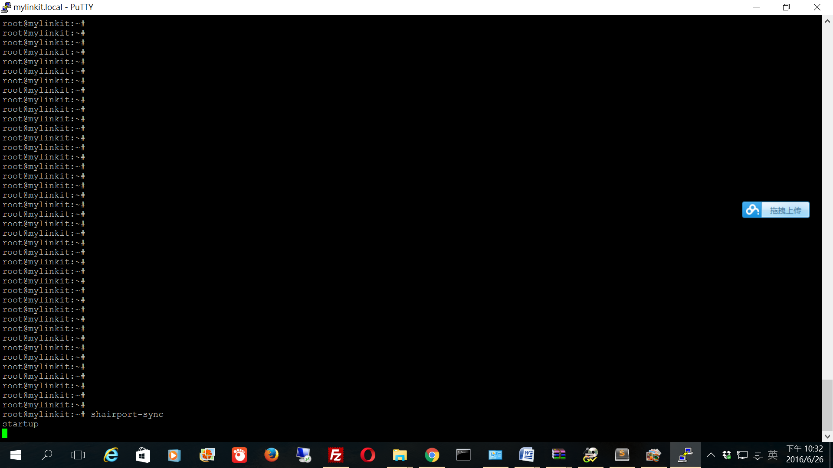

用iPad(audials app)設置airplay接收器

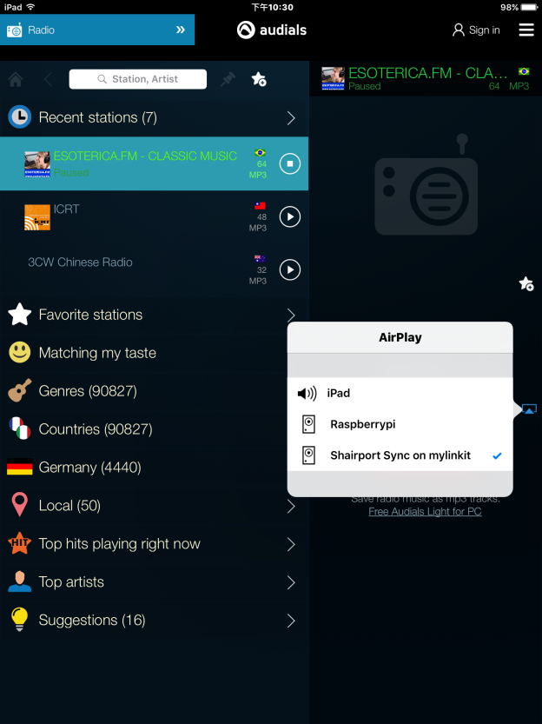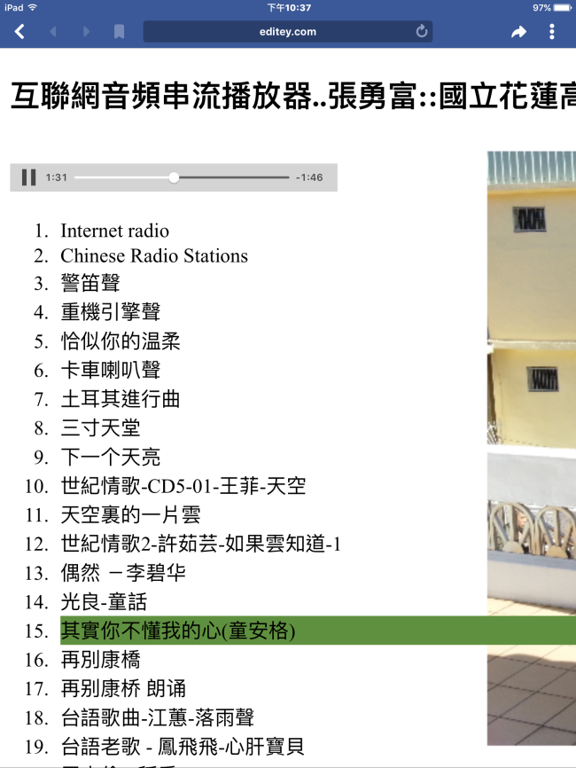

## [互聯網音頻串流播放器..張勇富::國立花蓮高級工業職業學校](http://www.editey.com/preview/0B_lFhYyj4JwRSDZYenNQcUxjNms/Audio_ex2.2.html?email=changleeyipun%40gmail.com)

測試成功2016/6/26

reboot 測試

#wget -O - http://50.7.96.210:8360 | madplay - -a+5 -o wave:- | aplay -D plughw:1

#shairport-sync -d #在後台運行

